SMART TICKETING SYSTEM IN METRO RAIL
Arun Francis G¹, Gowtham D², Pavithran K S²,Sridhar A², Veerapandian C²
Assistant professor¹, Student²
ja.arunji@gmail.com¹, gowtham97869@gmail.com²
Department of Electronics and Communication Engineering,
Karpagam College of Engineering, Coimbatore-641032.

Abstract- Railways are one of the most important modes of travel all over the world. So, all their operative procedures have to be simplified for deriving the best results. One such technology employed for providing the best service by the railways is the RFID railway reservation technology. It simplifies the process of the effort of the passengers without causing any problems. The major benefit of such a system is in simplification of the ticket checking system. The ticket inspection system now consists of a simple verification of the RFID tag which is possessed by the people. Also, this system is completely faultless and fool proof.
Since the number of customers going through the railways has enriched to such a large extent, the operational difficulties faced the organizations has increased considerably. With the work of RFID, it can hope to get rid of its many problems like increasing capital spending and debt management. This technology can help such organizations like railways in associating their revenues while cutting costs through better operations and ability operation. The execution of the RFID in the railways can provide knowledge about the exact location of a particular person or his baggage. The RFID systems operated by the railways help them in making exact decisions about managing the passage occurring through the railways. Every operation of

railways like train organizing, train dispatching and managing train throughput can become hassle-free after the introduction of such systems. It will become humbler and easier for Railways to control the system of load billing with the help of this technology.
I.INTRODUCTION

Radio Frequency Identification (abbreviated as RFID) has been an evolving technology in recent years. RFID technology can be effectually employed in number of applications due to its desire for efficiency. Radio Frequency Identification (RFID) is a generic term for skills that use radio waves to automatically identify and trajectory product, animal, or person by means of using RFID tags that are applied or incorporated on them. An RFID scheme consists of a tag, basically a microchip with an antenna and an interrogator or reader with an antenna. A fundamental system of RFID consists of two primary modules: The reader circuit and tag. The RFID tag and the reader circuit set up message via waves of electromagnetic nature. This work recommends the use of RFID technology with Embedded system to provide an improved and efficient automatic train ticketing system with RFID tag. An efficient utilization of RFID with Embedded System facilitate the smart ticketing in metro trains is projected. This system describes the installation of RFID reader circuit in each and every train stations in metro rail to simplify the calculation of ticket charges and valid time This task is applied by using an automated Database system which makes the transactions faster, easier and free of indistinctness. This system very beneficial for passengers.
RFID MODULE:
The EM-18 RFID Reader module operating at 125kHz is an low-cost solution for your RFID based application. The Reader module comes with an on-chip antenna and can be power-driven up with a 5V power supply. Power-up the module and connect to the transmit pin of the module to recieve pin of your microcontroller. Show your card within the reading distance and the card number is thrown to the output.The module can be configured for also a weigand output.
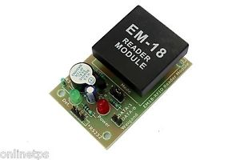
Figure 1. RFID Module
An RFID system consists of two separate components tag and reader. Tags are similar to barcode labels, and come in different shapes and sizes. The tag contains an antenna connected to a small microchip containing up to 2 kilobytes of data. The reader, or scanner, functions similarly to a barcode scanner.However, while a barcode scanner uses a laser beam to scan the barcode, an RFID scanner routines electromagnetic waves. To transmit these waves, the scanner uses an antenna which transmits a signal, communicating with the tags antenna. The tags antenna receives data from the scanner and transmits its precise chip information to the scanner.
The data on the chip is usually stored in one of two types of memory and the most common is Read-Only Memory (ROM) as its name proposes read-only memory cannot be altered once programmed onto the chip during the manufacturing process. The next type of memory is Read/Write Memory though it is also programmed during the manufacturing process, it can later be altered only by certain devices.
The RFID tag contains powered or non-powered microchip and an antenna. There are three different types of tags.
Passive tags is the simplest, smallest and cheapest version of an RFID tag as they do not contain a built-in power source and subsequently cannot initiate communication with a reader. As the available power from the reader field contracts rapidly with distance, passive tags have practical read ranges that vary from about 10mm up to 5 metres.
Semi-passive tags have built-in batteries and they do not require energy from the reader field to power the microchip. This allows them to function with much lower signal power levels and act over bigger distances.
ARDUINO UNO:
Arduino Uno is a microcontroller board based on the ATmega328P which has 14 digital input/output pins, 6 analog inputs, a 16 MHz quartz crystal, a USB connection, a power jack, an ICSP header and a reset button respectively. It contains all needed to support the microcontroller simply connect it to a computer with a USB cable or power it with a AC-to-DC adapter or battery to get started.
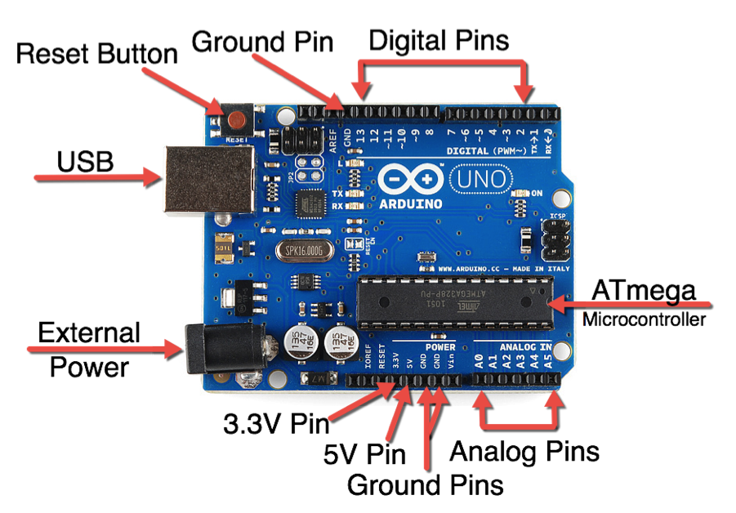
Figure 2.Arduino UNO
ARDUINO UNO TO ATMEGA328 PIN MAPPING:
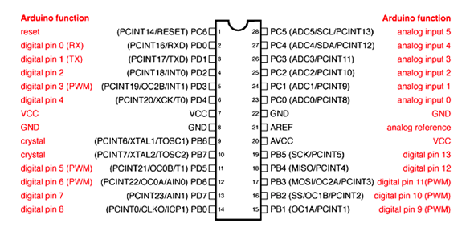
Figure 3.ATMEGA328 Pin Mapping
DC MOTOR:
A DC motor is a type of motor within a class of electrical machines whereby direct current electrical power is converted into mechanical power. These type of motor relies on forces that magnetic fields produce. Unrelatedly of the type, DC motors have some kind of internal mechanism, which is electronic or electromechanical. In both cases, the direction of current flow in part of the motor is changed occasionally.
Here we are using 12V DC 60 RPM motor and 60RPM Centre Shaft Economy Series DC Motor has high quality and low cost DC geared motor. It has fortify gears and pinions to ensure longer life and better wear and tear properties. The gears are fixed on hardened steel shafts polished to a mirror finish and the output shaft rotates in a plastic bushing. The whole assembly is covered with some plastic ring. Gearbox is sealed and lubricated with a lithium grease and require no maintenance. The motor is screwed to the gearboxfrom inside.
Even though motor gives 60 RPM at 12V but motor runs smoothly from 4V to 12V and gives wide range of RPM, and torque. RPM and no load current as a function of voltage and stall torque and stall current as a function of voltage.
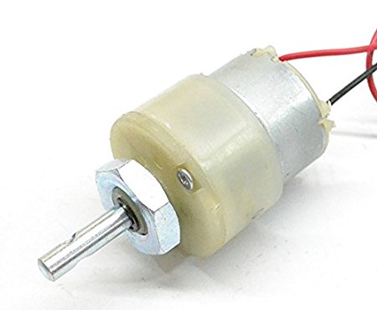
Figure 4.DC Motor.
BUZZER:
The Piezo Buzzer Produces Sound Based on Converse of the Piezoelectric effect. The generation of pressure variation or strain by the application of electric potential across a piezoelectric material is the original principle. These Buzzers can be used alert a user of an event corresponding to a switching action, counter signal or sensor input and they are also used in alarm circuits and the buzzer produces a same noisy sound irrespective of the voltage variation applied to it.It consists of piezo crystals between two conductors when a potential is applied across these crystals they push on one conductor and pull on another this push and pull act results in a sound wave.Most buzzers produce sound in the range of 2 to 4Khz.
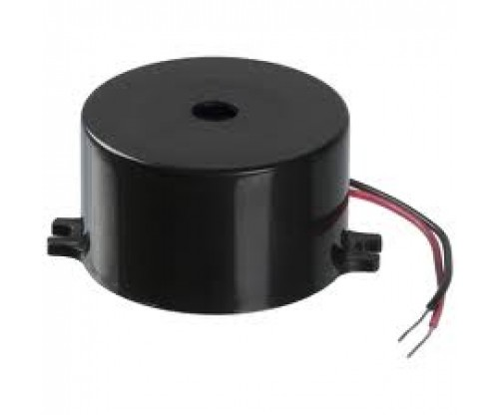
Figure 4.Buzzer
Block Diagram of the Project:
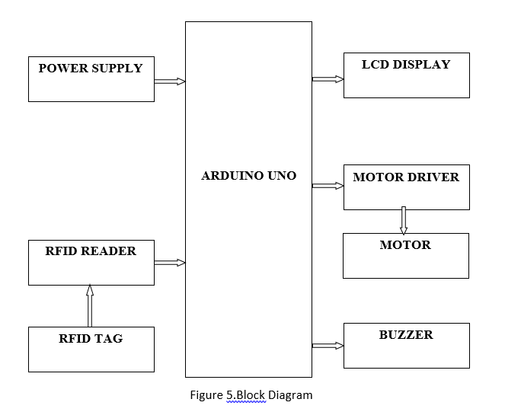
Description Of Block Diagram
The main advantage of the RFID tag is that each tag has a exceptional sequence number and hence there is no possibility of duplication . Also, the cost of manufacturing a RFID tag is considerably less. Hence it makes the availability of RFID Tags to the public a feasible option.
The recommended system RFID reader circuit is installed at the entry point and at the exit of the platform gate . When the passenger enters the platform gate the passenger should display the tag in front of the reader circuit placed in the platform gate.we have time then only door will open or door will not open The detailed operation of the system.
The RFID reader will be initialized and would be in the reading mode and hence a message will be displayed on the screen to asking the passengers to please swipe his/her certain RFID card. As soon as a passenger swipes his/her card across the RFID reader, the RFID reader reads the card and transfers the 12 bit unique code of the particular card to the microcontroller at 9600 baud rate and then the microcontroller detects that particular passenger and displays his/her name on lcd by associating his card’s no. with the database inside of it. Then next thing done is diagnosing which turn or chance is that particular passenger is using for using the power port for reviving. Then according to the no, of chance of that passenger the microcontroller closes the relay for that specific period of time which is mentioned for that particular turn.
CIRCUIT DIAGRAM:
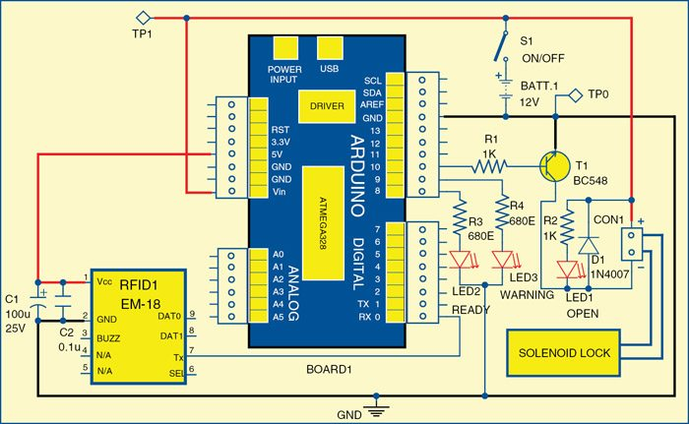
ARDUINO IDE:

The software for this project which was written in Arduino programming language. The Arduino UNO is programmed using Arduino IDE software and Atmega328 on Arduino UNO comes with a boot loader that allows you to upload new code to it without the use of external hardware programmer respectively.They communicates using STK500 protocol in which You can also bypass the boot loader and program the microcontroller through in-circuit serial programming (ICSP) header, but with boot loader the programming is rapid and easy.
CONCULSION AND FUTURE SCOPE:

Even though numerous limitations and unresolved issues still hamper the widespread application of RFID. Despite of all these challenges, RFID continues to make inroads into inventory control systems, and it’s only a matter of time before the component costs fall low enough to make RFID an attractive economic intention. Furthermore,wide-ranging engineering efforts are under way to overcome current technical restrictions and to build accurate and reliable tag reading systems.
In order to implement existing system of “RFID based swipe card draw power in Indian Railways” the embedded systems plat- form has utilized. And hence this suggested project seems to brought about equality among masses and also conserve the power
The scope for the project RFID based fast Ticketing System for Local Trains has thus been systematically studied and also the implementation of the same has been taken care of successfully. Even if currently this system is meant to be executed just for academic project purpose but the motive behind this project is to actually create a revolution in the ticketing world for the ease of the commuters in the 22nd century.

REFERENCES:
[1]. 2009 First International Workshop on Near Field Communication “NFC Ticketing: a Prototype and Usability test of an NFC-based Virtual Ticketing application”.
[2]. Existing scenario of near field communication in transport sectorGautam, J. ; Kumar, Y. ; Gupta, A. Signal Processing and Integrated Networks (SPIN), 2014 International Conference on DOI: 10.1109/SPIN.2014.6776972Publication Year: 2014 , Page(s): 327 – 332
[3]. A Distributed Integrated Fare Collection and AccountingSystem for Metropolitan Railway Transit Pint sangChang Ubiquitous Intelligence & Computing and 9th International Conference on Autonomic & Trusted Computing (UIC/ATC), 2012 9th International Conference on DOI: 10.1109/UICATC.2012.147 Publication Year: 2012 , Page(s): 797 – 802.

